**FURNITURE**

Created by:-

VIRAL MANDAVIYA

**Table of Contents**

1. **Introduction**
2. **System Requirements**
3. **Project Analysis**
4. **Project Design**
5. **Conclusion**

Chapter-1

**Introduction**

Topics:

* 1. Project Summary
  2. Purpose of Project
  3. Scope of Project
  4. Technology and Literature Review
  5. Project Summary

The Carpooling Platform Development project aims to create a user-friendly and efficient online platform that connects commuters looking to share rides for their daily commutes or occasional trips. The platform will facilitate carpooling arrangements to reduce traffic congestion, promote eco-friendly transportation, and provide cost-saving opportunities for users.

Key Objectives:

1. User Convenience: Provide a convenient and accessible platform for users to find, offer, and coordinate rides with others.
2. Traffic Reduction**:** Decrease the number of single-occupancy vehicles on the road, contributing to reduced traffic congestion and environmental impact.
3. Cost Savings: Help users save money on transportation costs by sharing expenses with fellow carpoolers.
4. User Safety: Implement safety measures, including is user verification, messaging, and reviews, to ensure a secure carpooling experience.
5. Reduced Parking Demand: Decrease the demand for parking spaces in crowded urban areas by promoting shared rides. Help address parking shortages and reduce the need for additional parking infrastructure.
6. Environmental Impact Reduction: Decrease greenhouse gas emissions and air pollution by reducing the overall number of vehicles on the road. Promote eco-friendly transportation options and contribute to a greener environment.
   1. Purpose of Project

The purpose of a carpooling project is to address various transportation challenges and promote a more sustainable and efficient way of commuting by encouraging people to share rides in a single vehicle. The primary purposes of a carpooling project include:

1. Traffic Reduction: Carpooling helps reduce the number of single-occupancy vehicles on the road, leading to decreased traffic congestion during peak hours. This, in turn, results in shorter commute times and less frustration for commuters.
2. Environmental Impact Reduction**:** Carpooling contributes to reducing the carbon footprint of transportation by lowering the number of vehicles emitting pollutants. Fewer vehicles on the road mean less air pollution, reduced greenhouse gas emissions, and a positive impact on air quality and the environment.
3. Cost Savings: Carpooling offers financial benefits to participants by allowing them to share the costs of fuel, maintenance, tolls, and parking fees. It provides an economical alternative to owning and operating individual vehicles.
4. Energy Efficiency: Carpooling optimizes the use of vehicles by maximizing passenger occupancy. This results in improved energy efficiency, as more people share the same vehicle, reducing energy consumption per passenger mile travelled.
5. Safety and Trust: Many carpooling services implement safety features such as user verification, background checks, and rating systems to ensure the security of users. This builds trust within the carpooling community.
6. Flexible Commuting Options: Carpooling projects offer flexibility in ride scheduling, accommodating different commuting needs and preferences. Users can choose one-time rides or regular carpooling arrangements
   1. Scope of Project

The Scope of Car-pooling project is:

* User Registration and Authentication: Users can create accounts, log in, and verify their identities.
* Profile Management: Users can create and manage their profiles, including personal information, contact details, and vehicle details.
* Ride Posting and Searching: Users can post ride offers and search for available rides based on location, date, and time.
* Messaging System: A messaging system allows users to communicate with each other for coordinating rides.
* Reviews and Ratings: Users can leave reviews and ratings for each other to build trust within the community.
* Notifications: Users receive notifications for ride requests, messages, and updates.
* Safety and Security: Implement safety measures, such as user verification and background checks, to ensure user safety. Provide a reporting system for users to flag inappropriate behaviour or safety concerns
* Maps and Directions: Integration of mapping and navigation services to provide route information.
* Legal and Privacy Compliance: Ensure the platform complies with data protection and privacy laws.
* Responsive Design: Design the platform to be responsive, adapting to different screen sizes and devices (desktop, tablet, mobile).
  1. Technology and Literature Reviews

**1.** Introduction: Carpooling, also known as ride-sharing or car-sharing, is a transportation concept that involves multiple individuals sharing a single vehicle for a common journey. Carpooling has gained significant attention in recent years as a sustainable and cost-effective solution to address urban congestion, reduce greenhouse gas emissions, and promote eco-friendly transportation. This technology and literature review aim to explore the key technological aspects, trends, and research findings in the field of carpooling.

**2.** Carpooling Platforms and Mobile Applications: Carpooling platforms and mobile applications have revolutionized the way people share rides. Prominent examples include BlaBlaCar, UberPOOL, and Lyft Line. These platforms offer user-friendly interfaces that allow individuals to:

* Register and create profiles.
* Post ride offers, specifying origin, destination, date, time, and available seats.
* Search for available rides based on location, schedule, and preferences.
* Communicate with co-riders through integrated messaging systems.
* Leave reviews and ratings to enhance trust and accountability.

**3.** Location-Based Services (LBS) and Mapping: Location-based services (LBS) and mapping technologies play a crucial role in carpooling applications. GPS and geospatial data are used for:

* Accurate location tracking.
* Real-time navigation and route calculation.
* Mapping interfaces that display routes, pickup/drop-off points, and estimated travel times.

**4.** Security and Privacy: Security and privacy are paramount in carpooling applications. Robust measures include:

* User authentication and authorization.
* Data encryption to protect user information.
* In-app reporting systems for safety concerns.
* Transparent privacy policies to build user trust.

**5.** User Experience (UX) Design: UX design principles guide the creation of user-friendly carpooling apps. Key considerations include:

* Intuitive user interfaces that simplify ride posting and booking.
* User onboarding processes that minimize friction.
* Usability testing to ensure seamless navigation and positive interactions.

**6.** Environmental Impact Studies: Research on carpooling's environmental impact highlights its role in reducing emissions, fuel consumption, and traffic congestion. Studies suggest that widespread carpooling adoption could significantly contribute to sustainability goals.

**7.** User Behavior and Adoption: Understanding user behavior and adoption patterns is critical. Studies delve into factors influencing carpooling decisions, including cost savings, convenience, and environmental consciousness.

**8.** Challenges and Solutions: Challenges in carpooling encompass trust issues, user participation, and scalability. Research explores innovative solutions, such as enhanced verification processes, gamification strategies, and dynamic pricing models, to address these challenges.

**9.** Future Trends: The future of carpooling holds exciting possibilities. Emerging trends include the integration of electric vehicles, autonomous driving technologies, and mobility-as-a-service (MaaS) concepts. These innovations are poised to reshape the carpooling landscape.

**10.** Conclusion: This technology and literature review provide insights into the evolving landscape of carpooling. Technological advancements, coupled with research findings, have positioned carpooling as a sustainable, cost-effective, and eco-friendly mode of transportation. As urbanization and environmental concerns continue to grow, carpooling is poised to play a pivotal role in shaping the future of mobility.

Chapter-2

**SYSTEM REQUIREMENTS**

Topics:

* 1. Role details
  2. Hardware and Software Requirements
  3. Constraints

2.1 Role details

In this system there are three types of user:

1. Administrator

2. Driver

3. Passenger

Task of Administrator:

* Login: The administrator can log in with their credentials to access the administrative dashboard.
* Manage Routes: Create, edit, and delete carpooling routes within the system.
* Manage Drivers: Add and remove drivers from the platform.
* Manage Passengers: Add and remove passengers from the platform.
* View Ride Statistics: Access data and statistics related to carpooling rides.
* Manage Feedback: Handle user feedback and ratings to ensure a safe and reliable carpooling service.
* Manage Payment Service : Handle User payment and driver payment

Task of Driver:

* Registration: Drivers can register for an account by providing their personal information and vehicle details.
* Login: Log in using their registered credentials.
* Forgot Password/Change Password: Reset forgotten passwords or change their existing passwords.
* Vehicle Registration: Driver register his/her vehicle in system.
* Offer Rides: Create ride listings, specifying the route, date, time, and available seats.
* Manage Rides: Edit or cancel ride listings as needed.
* View Passenger Requests: Accept or decline ride requests from passengers.
* Track Rides: Access navigation tools or GPS integration to help with route navigation.
* Accept Payment: Driver also accept direct payment by passenger.

Task of Passengers:

* Registration: Passengers can register for an account by providing their personal information.
* Login: Log in using their registered credentials.
* Forgot Password/Change Password: Reset forgotten passwords or change their existing passwords.
* Search for Rides: Search for available rides based on their desired route and time.
* Request Rides: Send ride requests to drivers, specifying their travel preferences.
* View Ride Confirmations: See whether their ride requests have been accepted by drivers.
* Track Rides: Access real-time information about the status and location of the ride.
* Payment: Passenger can do direct payment via UPI or wallet in website or can do direct payment to driver via cash or UPI.

2.2 HARDWARE& SOFTWARE REQUIREMENTS

The Hardware and Software requirements for car-pooling website:

Hardware Requirements:

1. Web Hosting Server:
   * A powerful web server to host your website.
   * Suggested options include dedicated servers, virtual private servers (VPS), or cloud-based solutions like AWS, Azure, or Google Cloud.
2. Database Server:
   * A database server to store user data, ride information, and other relevant data.
   * Common choices are MySQL, PostgreSQL databases like MongoDB.
3. Network Infrastructure:
   * Reliable internet connectivity to ensure your website is accessible 24/7.
   * Secure sockets layer (SSL) certificate for data encryption.
4. Load Balancers (Optional):
   * If your website experiences high traffic, consider load balancers to distribute traffic across multiple servers for better performance and redundancy.
5. Backup and Recovery Systems:
   * Regular automated backups of your database and website files.
   * A disaster recovery plan in case of hardware failure or data loss.

Software Requirements:

1. Web Development Technologies:
   * Programming languages like HTML, CSS, and Javascript for front-end development.
   * Backend development can be done using Python.
2. Web Frameworks:
   * Utilize web framework Django (Python) to streamline development.
3. Database Management System (DBMS):
   * Choose a DBMS to manage your data like MySQL.
4. Web Server Software:
   * Deploy a web server software such as Apache, Nginx, or Microsoft Internet Information Services (IIS) to serve your web application.
5. Version Control:
   * Use version control systems like Git to manage your project's source code.
6. Security Measures:
   * Implement security protocols like HTTPS, user authentication, authorization, and data encryption to protect user information.
   * Regularly update and patch your software components.
7. Payment Gateway Integration:
   * If you plan to charge users for services, integrate a payment gateway such as PayPal, Stripe, or a bank's payment API.
8. Mapping and Geolocation APIs:
   * Utilize mapping and geolocation APIs like Google Maps to provide location-based services and route planning.
9. Communication APIs:
   * Implement APIs for email notifications, SMS alerts, and in-app messaging to facilitate communication between users.
10. Analytics and Monitoring Tools:
    * Use analytics tools like Google Analytics or custom monitoring solutions to track website traffic and performance.
11. Content Delivery Network (CDN):
    * Consider using a CDN to optimize content delivery and reduce latency for users in different geographical locations.
    * Development Tools and IDEs:
    * Use integrated development environments (IDEs) such as Visual Studio Code, PyCharm, or Sublime Text for coding and debugging.

System Requirement:

1. Server Configuration:

* Pentium IV 800 MHz CPU onwards
* 1GB RAM
* Minimum 3GB free space of HDD

1. Client Configuration:

* Pentium IV 500 MHz CPU onward
* 1GB RAM

1. Software Requirements:

* Visual Studio 2010
* SQL Server 2008 R2
  1. CONSTRAINTS

Parallel Operation:

The carpooling website is designed to facilitate parallel operation, allowing multiple users to access the platform simultaneously. This means that numerous users can use the website concurrently, making it efficient and user-friendly.

Reliability Requirement:

Our carpooling system is highly reliable when used within the defined specifications. Users can depend on the platform to provide consistent and dependable carpooling services as long as it's utilized as intended.

Security:

Security is a top priority in our carpooling website project. Every sub-module within the system has been meticulously designed with robust security measures. The use of ASP.NET ensures a secure environment. Additionally, class members are restricted from being accessed outside the package, reducing the risk of unauthorized access. The system's design incorporates a limited number of entry and exit points within each class, minimizing the potential for external tampering.

Interface Design:

The user interface design plays a pivotal role in enhancing user experience and communication. Our carpooling website prioritizes effective communication with users. We follow established interface design principles to create a user-friendly environment. This includes designing interface objects and actions and structuring screen layouts that form the foundation of a user interface prototype.

Hiding Technical Internals:

We ensure that users are not burdened with concerns related to the operating system, file management, or other intricate computing functions. The interface abstracts away these technical details, allowing users to interact with the system at a higher, more user-friendly level. Users are not required to issue operating system commands or perform low-level tasks within the software.

Chapter No: 3

**SYSTEM ANALYSIS**

Topics:

3.1 Problem Definition

3.2 Fact Finding Technique

3.3 Need for Computerization

3.4 Process Model

3.5 Requirement Analysis

3.6 Feasibility Study

3.7 Requirement Validation

3.8 Study of current version

3.9 Problem and weakness of current system

3.10 Requirement of new system

3.1 Problem Definition

Problem Statement: Traffic congestion, pollution, and the rising costs of commuting are persistent challenges in urban areas. These issues contribute to longer commute times, increased fuel consumption, and environmental concerns.

Objective: Our carpooling project aims to address these problems by providing an efficient and sustainable transportation solution. We seek to reduce the number of single-occupancy vehicles on the road, alleviate traffic congestion, lower carbon emissions, and make commuting more cost-effective and environmentally friendly.

3.2 Fact Finding Technique

Data Collection Methods: We employed a range of fact-finding techniques to gather valuable insights and requirements for our carpooling project:

1. Surveys: We conducted surveys to collect quantitative data about commuter preferences, pain points, and habits.
2. Interviews: Interviews with potential users and stakeholders provided qualitative insights into their needs and expectations.
3. Market Research: Extensive market research allowed us to understand the competitive landscape, identify opportunities for differentiation, and gain industry insights.

Key Findings:

* Commuters face challenges in finding suitable carpooling matches.
* Safety, trust, and efficient communication are key concerns.
* There is a growing demand for sustainable transportation alternatives.

3.3 Need for Computerization

Limitations of Manual Carpooling: Traditional carpooling methods often suffer from inefficiencies, including:

* Manual ride coordination
* Limited accessibility
* Communication challenges

Benefits of Computerization: Our carpooling project seeks to overcome these limitations by introducing computerization. This will result in:

* An efficient and user-friendly platform
* Scalability to accommodate a growing user base
* Enhanced accessibility and environmental benefits

3.4 Process Model

Agile Development Methodology: We have chosen the agile development methodology for our carpooling project. Agile's iterative approach aligns with our project's dynamic nature. It enables us to:

* Continuously gather user feedback
* Adapt to changing requirements
* Deliver a user-centric platform efficiently

3.5 Requirement Analysis:

Functional Requirements: Our carpooling platform will feature the following functionalities:

* User Registration: Users can create accounts with their details and preferences.
* Ride Scheduling: Users can schedule rides, specify pick-up and drop-off points, and set ride preferences.
* Payment Processing: A secure payment system for transactions within the platform.
* Communication Features: In-app messaging and notification system to facilitate user communication.

Non-Functional Requirements:

* Security: Robust security measures to protect user data and transactions.
* Performance: Ensuring the platform's responsiveness and reliability, even under heavy usage.
* Scalability: Designing the system to accommodate a growing user base.

3.6 Feasibility Study

Feasibility Assessment: Our feasibility study indicates that the carpooling project is:

* Technically Feasible: We have the necessary technology and expertise.
* Economically Viable: The project aligns with our organization's goals and has a favourable return on investment.
* Operationally Sound: The platform can be efficiently managed.
* Scheduling Feasibility: The project timeline is achievable.

3.7 Requirement Validation

Validation Methods: We used rigorous validation methods, including:

* Prototyping: Creating interactive prototypes to gather user feedback early in the development process.
* User Acceptance Testing: Involving users in testing the system against defined acceptance criteria.

Validation Outcomes:

* The requirements were validated to ensure their accuracy and completeness.
* User feedback confirmed that the platform meets their expectations and functional needs.

3.8 Study of Current Version

Overview of Existing Solutions: While there are existing carpooling solutions, we observed several limitations, including:

* Inefficient ride matching and coordination processes.
* Limited route flexibility and accessibility.
* Lack of advanced features such as real-time tracking and integrated payment systems.

3.9 Problems and Weaknesses of Current

Identification of Issues: In-depth analysis revealed specific problems and weaknesses in current carpooling solutions:

* Inefficient ride matching leading to underutilized capacity.
* Safety and trust concerns due to limited user verification.
* Lack of robust communication tools hindering effective coordination.

3.10 Requirement of New System

New System Requirements: The new carpooling system will address these challenges and feature:

* Advanced ride matching algorithms for efficient ride coordination.
* Real-time tracking for enhanced safety and convenience.
* Robust user verification measures to establish trust among users.
* Seamless in-app communication tools to facilitate coordination and planning.

Chapter – 4

**Project Design**

Topics:-

4.1 User case Diagram (fig.1.1 to fig.1.3)

4.2 0 Level DRD (fig.1.4 to fig.1.6)

4.3 1st Level DRD (fig.1.7 to fig. 1.9)

4.4 ERD (fig.1.10 to fig.1.12)

4.1 User case Diagram

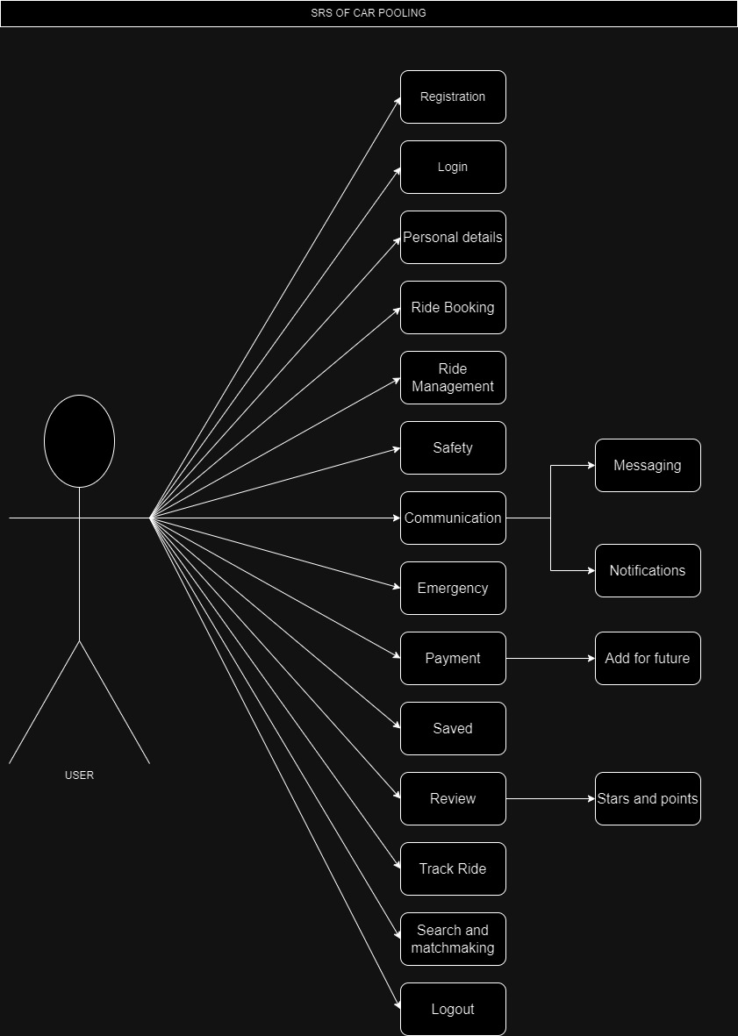

Fig.1.1 User case Diagram

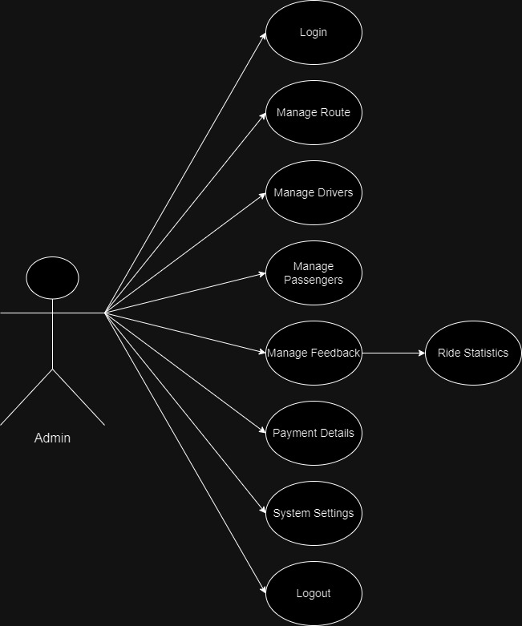

Fig 1.2 Admin case diagram

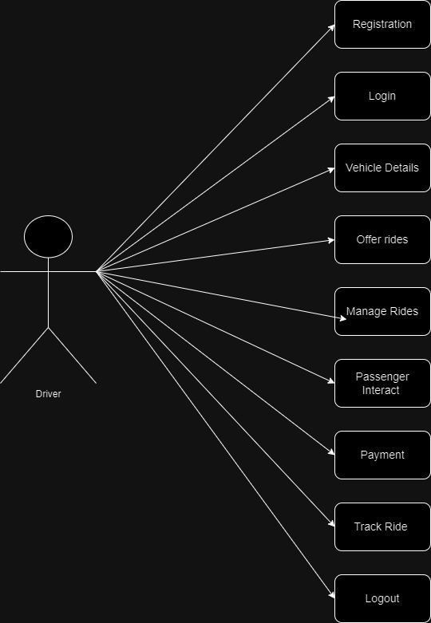

Fig 1.3 Driver case Diagram

4.2 0 Level DRD

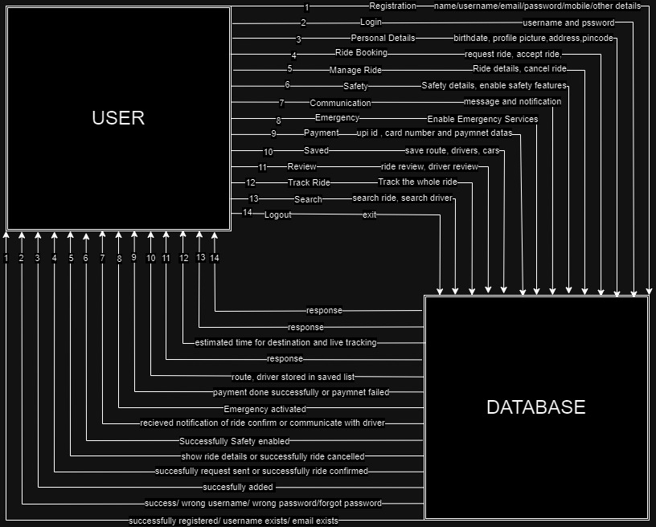

Fig 1.4 0 Level user DRD

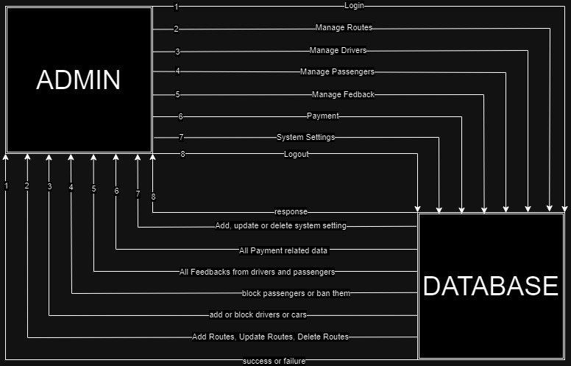

Fig 1.5 0 Level admin DRD

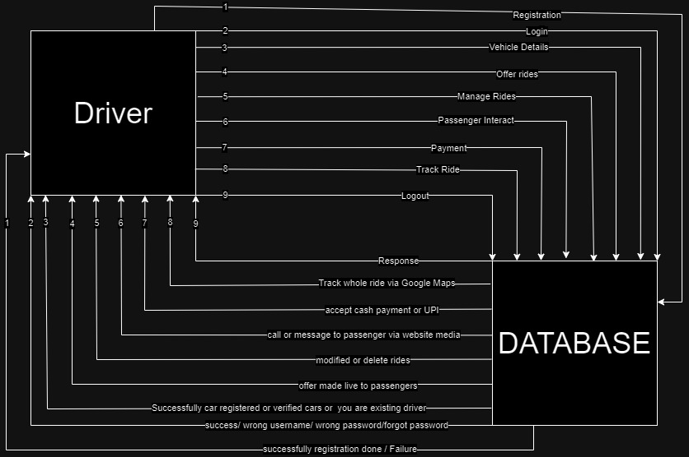

Fig 1.6 0 level driver DRD

4.3 1st Level DRD

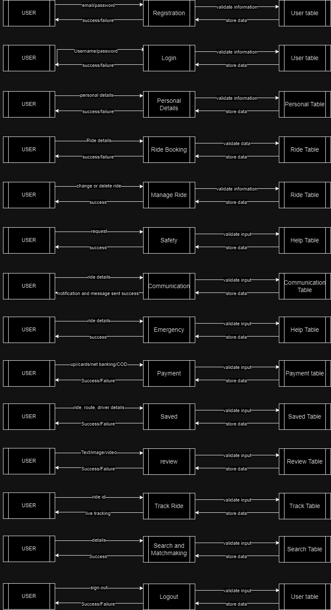

Fig 1.7 1st level user DRD

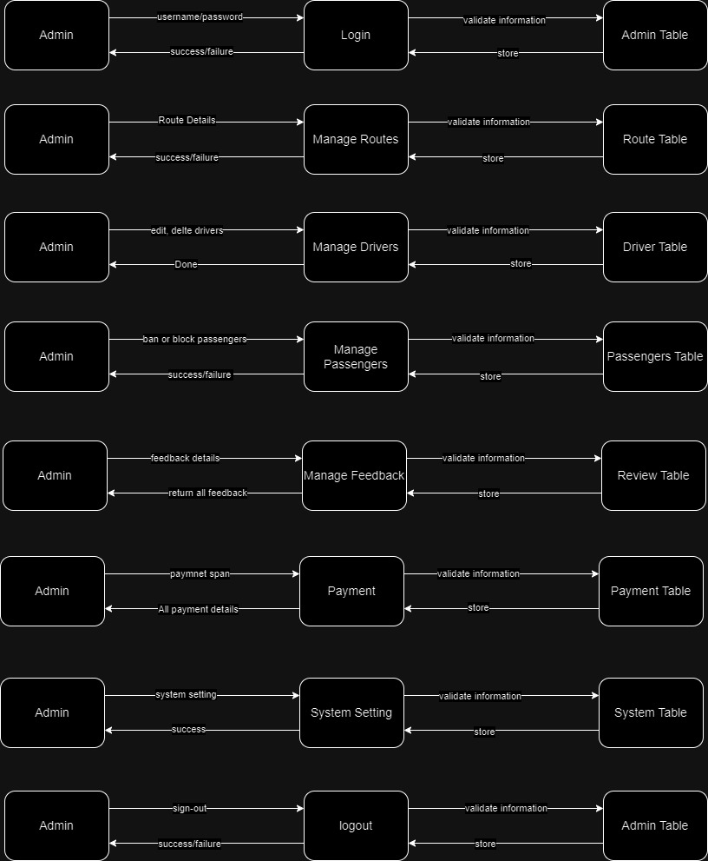

Fig 1.8 1st Level admin DRD

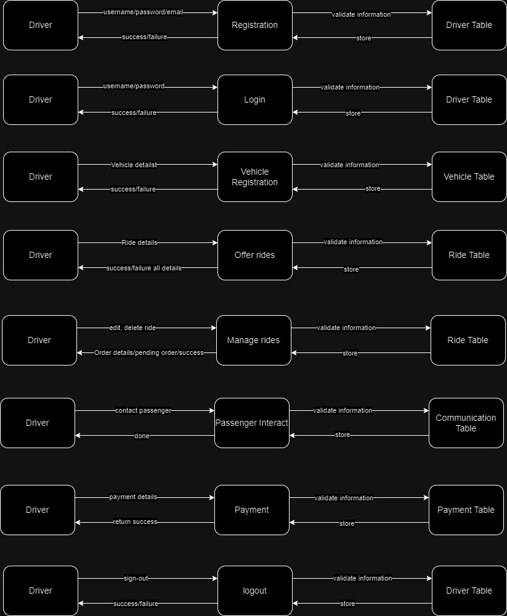

Fig 1.9 1st Level driver DRD

4.4 ERD

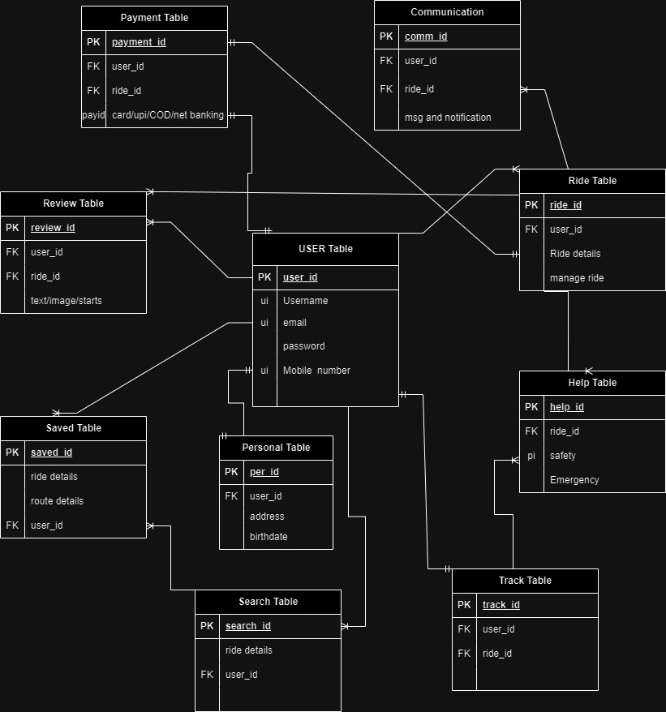

Fig 1.10 ERD user

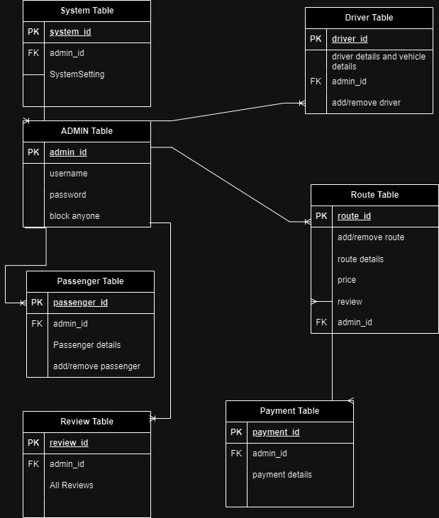

Fig 1.11 ERD admin

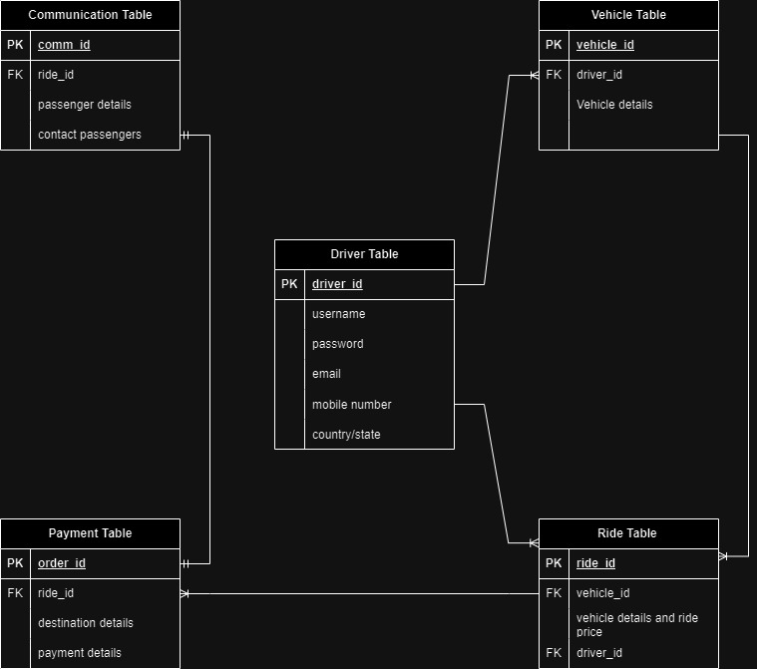

Fig 1.12 ERD driver

Chapter – 5

**Conclusion**

Conclusion:-

In conclusion, the carpooling website project holds significant promise in addressing the pressing issues of traffic congestion, environmental sustainability, and cost-effective transportation solutions. Throughout the project, we have successfully designed and implemented a user-friendly platform that encourages and facilitates carpooling among individuals, providing numerous benefits to both users and society as a whole.

Key highlights of the carpooling website project include:

1. Reduced Traffic Congestion: By connecting drivers and passengers with similar routes and destinations, our platform actively contributes to reducing the number of single-occupancy vehicles on the road. This, in turn, eases traffic congestion and leads to smoother and more efficient daily commutes.
2. Environmental Sustainability: Carpooling is a sustainable transportation option that reduces carbon emissions and the overall environmental impact of personal vehicles. Our project aligns with the global effort to combat climate change by promoting shared rides and reducing the carbon footprint of transportation.
3. Cost Savings: Users of our carpooling website experience cost savings through shared expenses, such as fuel and tolls. Carpooling allows individuals to split the cost of their journeys, making transportation more affordable for everyone involved.
4. Community Building: The platform fosters a sense of community by connecting people who share similar routes and interests. This not only promotes social interaction but also creates a safer and more enjoyable travel experience.
5. User-Friendly Interface: We have designed the website with a user-friendly interface that prioritizes ease of use and accessibility. Users can quickly and intuitively find carpooling opportunities, create profiles, and manage their rides.
6. Safety and Trust: Safety and trust are paramount in the world of carpooling. Our platform incorporates robust safety features, including user verification, driver background checks, and user reviews, to ensure a secure and reliable experience for all users.
7. Future Expansion: As the project continues to gain traction, we have plans to expand its reach and features. This may include integration with public transportation options, partnerships with businesses, and enhanced mobile applications.